



Testing Strategy



Updated ***On***

June 2, 2019

***Prepared By*** Debbie Smith

Brittany Coleman

Johnny Bolden

Wendie Titus

Table of Contents

Summary 1

Role and Responsibilities 1

Quality Center Access 3

Training 3

Requirements to Script Tracker 4

Test Script Process 6

Ongoing Solman to QC Requirements Sync Process 9

Quality Center User Guides 12

Support 12

# **Summary**

The Testing strategy will outline the administration, maintenance, and support for Customer Connects Quality Center along with guidelines for testing. The Testing Strategy ensures that our testing is managed and conducted for commonality by all, including but not limited to, Releases 1- 8, Security, Conversion and Production Support. This involves instilling rules and procedures for the use of the system and allowing users to achieve the routine operational tasks that maintain system upkeep.

The primary goals of the Testing Strategy are to:

* Define a strategy to ensure all teams are in accordance.
* Document the appropriate policies and procedures of the Customer Connect Quality Center
* Document the appropriate policies and procedures for testing
* Provide helpful resources to new and existing users.

**Risks/Concerns**

The following are risks to an effective strategy plan:

* Inadequate support from the Customer Connect QC Team to affect proper guidance.
* Administrators or users not abiding by the rules and policies illustrated in this document.
* Lack of understanding of certain functionalities and activities.

# **Role and Responsibilities**

**Purpose**: The Customer Connect testing team consists of administrators providing operational support for the system to help ensure the enforcement of the Testing Strategy.

The team manages Quality Center for:

* Structure set up
* Creating folders
* Granting user access
* Providing Quality Center training for users
* Uploading requirements from Solman
* Uploading test scripts
* Linking requirements to test scripts as provided by tower leads
* Monitoring and ensuring accurate information is captured in Quality Center
* Providing various reports to track script execution and defects

**Responsibilities**:

* **QC Structure:** The team will handle modifying any drop-down values contained in Quality Center or adding new fields to a module when necessary.
* **Defining folder structures in Test Plan/Test Lab:** Current folder structure is

Release🡪Testing Phase🡪Sprint or Cycle (Depending on phase)🡪Tower.

*If folder structure needs are different work with testing team to adjust.

* **Granting user access requests**: This includes submitting forms to request new users access to Quality Center and granting access to all who need access to the Customer Connect domain.
* **Providing Quality Center training**: Offering instructor-led sessions per request and delivering user guides for reference.
* **Uploading requirements:** All Approved requirements will be retrieved from Solman on initial sync between Solman and HPQC and then re-synced as often as necessary for changes made in Solman that need to replicate into HPQC.
* **Validating Requirements:** All updates/changes related to requirements must be made in Solman and synced to ensure Solman and Quality Center have the same Solman requirement # reference and information such as; verbiage, status, and assigned tower.
* **Uploading Test Scripts**: Importing an Excel file, that contains the test script(s), directly into Quality Center and coordinating with Tower Leads on any upload errors identified. Template can be found here: <Templates>
* **Linking requirements to scripts**: Each requirement will be linked to a test script to ensure traceability of all requirements and can be found by the script writer in the Script Tracker. This information is then provided to the testing team via the Test Script Upload template and requires manual association within Quality Center by the team.
* **Moving/Removing test scripts**: The team will be responsible for moving or removing any test scripts within Quality Center based on coordination with Tower Leads.
* **Reporting:** Providereports such as but not limited to: requirement coverage, daily test executions, defect detail inventory, and tester activity reports.

**Types of Quality Center User Roles**

* **Viewer:** User can ONLY view the Defects module, the Requirements module, and the Test Management module.
* **Tester:** User can execute scripts, create and link defects, edit/create test results, run steps, run status, and test instances. They can also manage Reports/Graphs in their private folder.
* **Developer:** User is an IT person who can create, receive and fix defects.
* **Release Functional Lead:** This role is only for Release Leads. In addition to all the “Tester” actions listed above, this role can generate/create/update Excel report queries, create graphs, and create/update requirements.
* **Administrator:** Administrators can perform all functionalities within Quality Center and are the only ones who can delete items from QC.

# **Quality Center Access**

1. Click on the following link <https://team.duke-energy.com/sites/CIS/SharedServices/Lists/TechServices%20Request%20Tool/AllItems.aspx#InplviewHash17eb2f98-2d43-429b-98ba-c3b1078df074=SortField%3DDueDate-SortDir%3DDesc-WebPartID%3D%7B17EB2F98--2D43--429B--98BA--C3B1078DF074%7D>
2. Fill out a request form.
3. Send to the Customer Connect QC Team.

Please reference this job aid when filling out the form [Quality Center ALM Access Request(Guide)](https://team.duke-energy.com/sites/CIS/testing/Test/Quality%20Center%20Documents/Quality%20Center%20User/Quality%20Center%20ALM%20Access%20Request(Guide).docx)

# **Training**

* Training tools include:
  + Instructor-led training on how to: Login to QC, execute test scripts, create defects, and best test practices.
  + Job Aid documentation on common Quality Center functions and script preparation. (<https://team.duke-energy.com/sites/CIS/testing/Test/Quality%20Center%20Documents/Quality%20Center%20User>)

# **Requirements to Script Tracker**

This diagram illustrates how the Tower Lead/Support Team Lead will manage requirements coverage and Script ID assignments to Script Writers. This process helps ensure that requirements are accurately covered throughout script preparation and execution. Trackers will be created at the start of the AT or PT phase for the Tower Leads to manage in partnership with the Test Team.

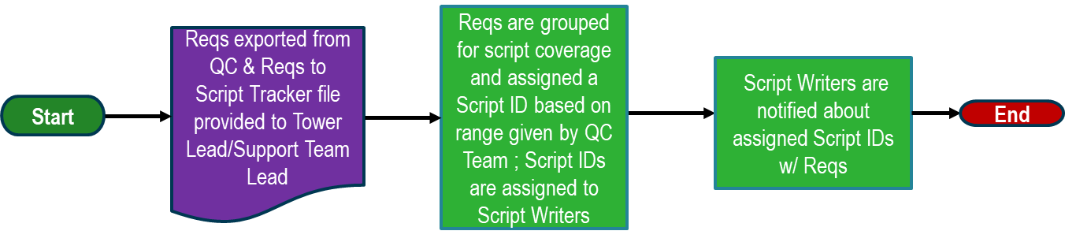

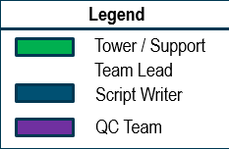

**QC Team provides the Requirements to Script Tracker file to the Tower Lead/Support Team Lead**

* QC Team exports Approved Solman requirements from Quality Center.
* The QC Team creates the Requirements to Script Tracker file for each Tower.
* Tower Lead/Support Team Lead are notified that the Requirements to Script Tracker is ready.
* The QC Team provides a range for Script ID #’s (i.e. 1000-1099) by Tower

Reqs exported from QC & Reqs to Script Tracker file provided to Tower Lead/Support Team Lead

**The Tower Lead/Support Team Lead groups Requirements for Script Coverage, assigns the requirements to Script IDs, and Script ID’s are assigned to Script Writers**

* The Tower Lead/Support Team Lead will categorize and group requirements into Scripts.
* The Tower Lead/Support Team Lead assigns requirements to Script IDs.
* For PT every requirement will be assigned at least one **Script ID**.
* Tower Lead/Support Team Lead creates Test Name for Script ID #.
* The Tower Lead/Support Team Lead assigns Script IDs to Script Writers.
* The Tower Lead/Support Team Lead sets the **Script Writing Start Date** and the **Script Writing Completion Date** using dropdown date selections.
* The Tower Lead/Support Team Lead defines the **Cycle(s)** of the Test Scripts.

Reqs are grouped for script coverage and assigned a Script ID based on range given by QC Team; Script IDs are assigned to Script Writers

# 

**The Tower Lead/Support Team Lead notifies Script Writers about Script IDs that are assigned.**

* The Tower Lead/Support Team Lead notifies Script Writers that they have Script IDs assigned to them.
* Script Writer uses provided Script Upload Template, saves as the Script ID-Script Name in assigned SharePoint Folder.
* Script Writers begin the script preparation process.

Script Writers are notified about assigned Script IDs w/ Reqs

**Requirements to Script Tracker Locations**

For each Release Team, the Requirements to Script Trackers will be located directly under their respective **Test** Folder. Production Support’s Requirements to Script Tracker will be located under the **Testing Documentation** Folder. [Quality Center User Tips](https://team.duke-energy.com/sites/CIS/testing/Test/Forms/AllItems.aspx?RootFolder=%2Fsites%2FCIS%2Ftesting%2FTest%2FQuality%20Center%20Documents%2FQuality%20Center%20User%2FQuality%20Center%20User%20Tips&FolderCTID=0x012000FB5AFEF84858384F9293A3BF28450412&View=%7B93A8F70D%2D32B7%2D4DAA%2D83B3%2D91D6906C2521%7D), screenshots and links regarding this process.

Tip document Sample: <https://team.duke-energy.com/sites/CIS/testing/Test/Quality%20Center%20Documents/Quality%20Center%20User/Sample%20for%20Script%20Tracker%20population.docx>

# **Test Script Process**

**2**

**Test Script Preparation for Execution**

The following diagram demonstrates the roles of the Tower leads, Script Writers, and Quality Center team during script preparation.

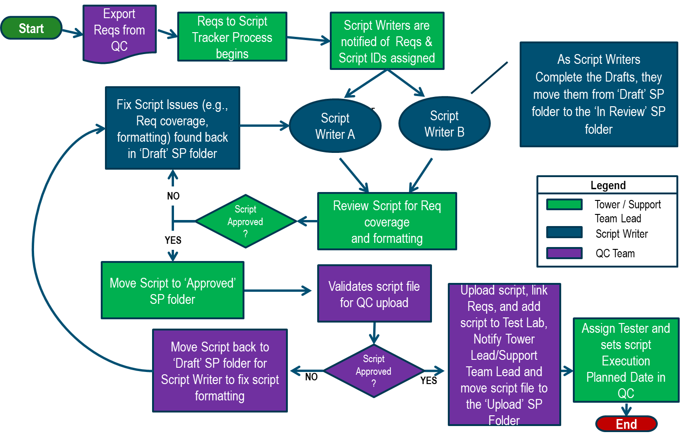

Export Reqs from QC

**The QC Team exports Requirements from Quality Center**

* The QC Team initially exports all Approved Solman requirements from Quality

Center.

* Ongoing sync between Solman and QC to ensure changes are reflected between both tools. (Sync process explained further in Document)

**The Requirements to Script Tracker Process Begins**

* This represents the initial Approved Solman requirements being placed into the Requirements to Script Tracker.
* Requirements are grouped for script coverage and assigned Script IDs.

Reqs to Script Tracker Process begins

**The Tower Lead/Support Team Lead notifies Script Writers of assigned Script IDs**

* The Tower Lead/Support Team Lead notifies and provides the Script Writers the requirements along with the Script IDs that are assigned to them

Script Writers are notified of Reqs & Script IDs assigned

**Script Writers Complete Drafts using the Script upload template**

* Use the ‘Draft’ SP folder to hold scripts
* Each Script should be in its own Excel spreadsheet from Script Upload Template for tracking purposes
* Script should have all required fields filled in
* Ensure the script covers the requirements assigned
* Ensure the requirements assigned are filled in on the template
* Ensure script is in numerical order
* Move completed script to the ‘In Review’ SP folder for Tower Lead/Support Team Lead review

As Script Writers

Complete the Drafts, they move them from ‘Draft’ SP folder to the ‘In Review’ SP folder

Review Script for Req coverage

and formatting

**Tower Lead/Support Team Lead Script Review**

* Confirm Script covers assigned requirement
* Review the script name/description is appropriate for the test
* Ensure each script has an individual file
* Confirm all fields are filled in
* Confirm all requirements assigned to a script id are covered within the Requirements Tracker file.
* Move Script with issues back to Draft Folder for the script writer to fix
* Notify the Script Writer of the script issues and the script moved by in Draft for updates
* Move script to the Approved folder for Quality Center upload

Fix Script Issues (e.g., Req coverage, formatting) found back in ‘Draft’ SP folder

**Script Writer fixes the script issue from the Draft SP folder**

* Ensure the correct Script Upload Template is used
* Ensure the formatting is correct and all required fills are filled in
* Update script steps to a job aid level of detail
* Updates script steps to confirm assigned requirement are covered
* Ensure Requirements covered are filled in the Script Upload template
* Confirm steps are numerical
* Confirm only 1 script ID per file and only 1 script name/description
* Move updated script back to In Review folder for Tower Lead/Support Team Lead to Review updates

**QC Team uploads approved/validated scripts found in Approved SP folder**

* Uploads script to QC Test Plan Tower folder as indicated in Script Upload template
* Link scripts to Requirements as indicated in Script Upload template
* Moves script to Test Lab under the cycle indicated in the Script Upload template
* Move uploaded file from Approved SP folder to the Uploaded SP folder.
* Notify Tower Lead/Support Team Lead that script has been uploaded and requires an assigned tester and planned execution date in Quality Center.

Upload script, link Reqs, and add script to Test Lab, Notify Tower Lead/Support Team Lead and move script file to the ‘Upload’ SP Folder

**Tower Lead/Support Team Lead assigns script tester and planned execution date**

* Update the Responsible Tester in QC Test Lab for the assigned Tester
* Update the Planned Execution Date in QC Test Lab for the uploaded script
* Confirm the script was loaded properly
* Monitor Tester activity for assigned script and Test Lab execution

Assign Tester and sets script Execution Planned Date in QC

**Test Scripts, Draft, In-Review, Approved, and Uploaded Folder Locations**

We have created the “**Test Scripts**” folder located under the **Test** folder of each Release, and under **Support/Testing Documentation** for Production Support. In the **Test Scripts** folder are the sub-folders **Draft**, **In-Review, Approved**, and **Uploaded**. These folders are to be used during the script preparation process.

Please Leverage helpful tip documents found here: [Quality Center User Tips](https://team.duke-energy.com/sites/CIS/testing/Test/Forms/AllItems.aspx?RootFolder=%2Fsites%2FCIS%2Ftesting%2FTest%2FQuality%20Center%20Documents%2FQuality%20Center%20User%2FQuality%20Center%20User%20Tips&FolderCTID=0x012000FB5AFEF84858384F9293A3BF28450412&View=%7B93A8F70D%2D32B7%2D4DAA%2D83B3%2D91D6906C2521%7D), they include screenshots and links regarding multiple processes outlined in this document.

**Common Scripts Location:**

We have also created a “Common Scripts” folder that contains generic, reusable scripts that the script writer can refer to in their scripts. Instead of the writer re-writing steps that are used repeatedly in multiple scripts (i.e login steps), the script writer can refer/note the generic script that they want embedded. Here is the location of the “Common Scripts” : <https://team.duke-energy.com/sites/CIS/testing/Test/Forms/AllItems.aspx?RootFolder=%2Fsites%2FCIS%2Ftesting%2FTest%2FWorking%20Documents%2FCommon%20Test%20Scripts&FolderCTID=0x012000FB5AFEF84858384F9293A3BF28450412&View=%7B93A8F70D%2D32B7%2D4DAA%2D83B3%2D91D6906C2521%7D>

# **Ongoing Solman to QC Requirements Sync Process**

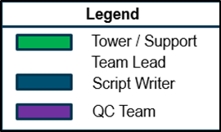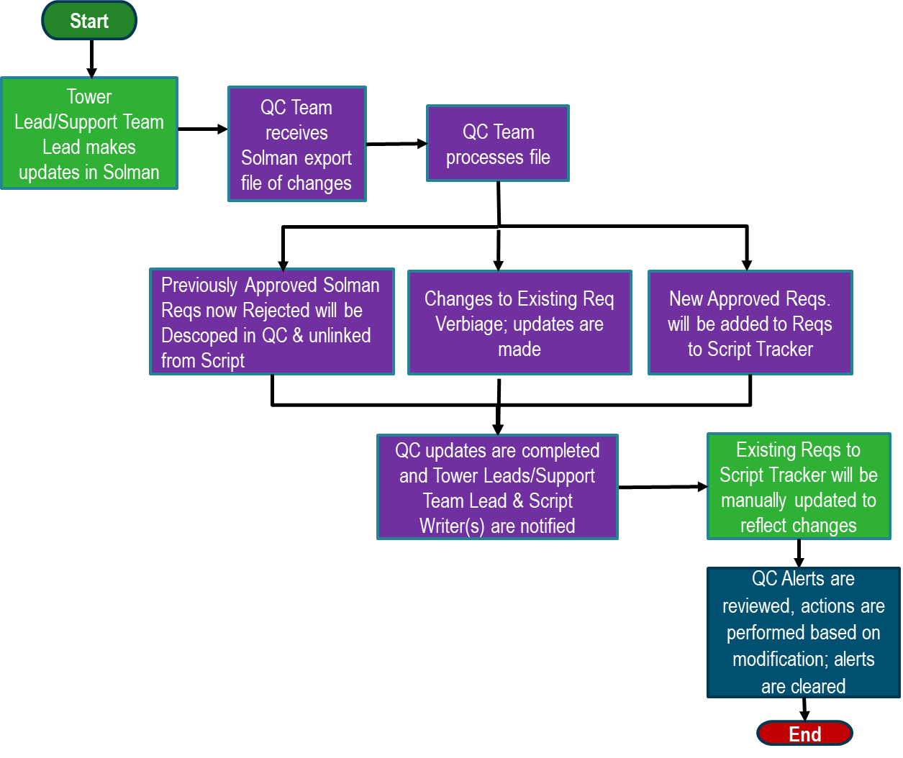

Tower Lead/Support Team Lead makes updates in Solman

**The Tower Lead/Support Team Lead makes updates in Solman**

* The Tower Lead/Support Team Lead will either reject the previously Approved Requirements, change requirement verbiage, or add new requirements into Solman.

**The QC Team receives Solman export file changes**

* The QC Team exports all the latest requirement changes from Solman.
* The frequency of the export from Solman are TBD based on volume of changes from Tower Leads/Support Team Leads.

QC Team receives Solman export file of changes

QC Team processes file

**The QC Team processes the Solman export file**

* The QC Team imports the Solman export file of changes into Quality Center to keep it in sync with Solman.

**Previously Approved Solman Requirements that are rejected will be descoped in Quality Center & unlinked from any Script**

* Requirements that were previously approved in Solman but get rejected will be descoped in Quality Center.
* All descoped requirements that are linked to script(s) will be unlinked from the script(s).

Previously Approved Solman Reqs now Rejected will be Descoped in QC & unlinked from Script

**Changes to Existing Requirement Verbiage updates are made**

* Quality Center will now have the latest updated requirement verbiage.

Changes to Existing Req Verbiage; updates are made

**New Approved Requirements will be added to Requirements to Script Tracker**

* The QC Team will export the new Approved Solman requirements from Quality Center and append them to the Reqs_to_Script Tracker file.

New Approved Reqs. will be added to Reqs to Script Tracker

QC updates are completed and Tower Leads/Support Team Lead are notified

**QC Updates are complete and Tower Leads/Support Team Leads and Script Writers are notified**

* The QC Team will notify the Tower Lead/Support Team Lead that the changes have been made to Quality Center.
* The QC Team will notify the Tower Lead/Support Team Lead if new requirements were appended to the Requirements to script Tracker.
* The QC Team will notify the Tower Lead/Support Team Lead if any of the previously approved requirements were rejected.
* The QC Team will notify the Tower Lead/Support Team Lead if there were any requirement verbiage changes.
* The Quality Center notification system will email Test Writer(s) about any requirement updates that were made to their scripts.
* Quality Center automatically place a red alert flag https://hpqualitycenteralm.duke-energy.com/qcbin/Help/doc_library/online_help/Content/UG/images/sl_trace_new.gif next to scripts that contain the modified requirements.

**Existing Requirements to Script Tracker will be manually updated to reflect changes**

* The Tower Lead/Support Team Lead will mark any requirements that are now rejected in the Requirements to Script Tracker.
* The Tower Lead/Support Team Lead will make updates on any requirements that have verbiage changes.
* The Tower Lead/Support Team Lead will assign new Requirements to script(s).

Existing Reqs to Script Tracker will be manually updated to reflect changes

QC Alerts are reviewed, actions are performed based on modification; alerts are cleared

**QC Alerts are reviewed; actions are performed based on modification; alerts are cleared in Quality Center**

* Script Writers review email notification to see which requirement(s) were modified.
* If requirement description is modified, Script Writer checks to see if requirement still applies to the script.
* If requirement no longer applies to the script, Script Writer must notify the Tower Lead/Support Team lead.
* Tower Lead/Support Team Lead notifies QC Team to unlink the requirement(s) from the script.
* Script Writers clear QC Alerts attached to their scripts in Quality Center.

**Summary of the Diagram**

* Tower Lead/Support Team Lead makes changes to requirements in Solman
* Solman needs to be synced to QC to ensure requirements and associated test scripts are accurate
* The frequency of the export from Solman are TBD based on volume of changes from Tower Leads/Support Team Leads
* Given only Approved requirements are initially exported to QC, only the status changes to those initial requirements plus any new Approved requirements will be synced to QC.
* The export of changes from Solman will be provided to the Tower Leads impacted, so they can ensure the changes are reflected in their Tower’s respective Requirements to Script tracker file.
* Script Writers will be notified of modified requirements that are attached to their scripts through the Quality Center Alert system.

# **Quality Center User Guides**

The following user guides provide step-by-step procedures on common Quality Center functions and operations.

[Quality Center ALM Access Request(Guide)](https://team.duke-energy.com/sites/CIS/testing/Test/Quality%20Center%20Documents/Quality%20Center%20User/Quality%20Center%20ALM%20Access%20Request(Guide).docx)

[Avoiding Multiple Runs in a Script(Guide)](https://team.duke-energy.com/sites/CIS/testing/Test/Quality%20Center%20Documents/Quality%20Center%20User/Avoiding%20Multiple%20Runs%20in%20a%20Script(Guide).docx)

[Customer Connect QC User Guide](https://team.duke-energy.com/sites/CIS/testing/Test/Quality%20Center%20Documents/Quality%20Center%20User/Customer%20Connect%20QC%20User%20Guide_v1.pptx)

[How to Assign a Tester & Planned Exec Date to a Script(Guide)](https://team.duke-energy.com/sites/CIS/testing/Test/Quality%20Center%20Documents/Quality%20Center%20User/How%20to%20Assign%20a%20Tester%20&%20Planned%20Exec%20Date%20to%20a%20Script(Guide).docx)

[How to Attach Screenshots or Documents to an Entire Script or a Step(Guide)](https://team.duke-energy.com/sites/CIS/testing/Test/Quality%20Center%20Documents/Quality%20Center%20User/How%20to%20Attach%20Screenshots%20or%20Documents%20to%20an%20Entire%20Script%20or%20a%20Step(Guide).docx)

[How To Set filters with conditions and Export in QC (Guide)](https://team.duke-energy.com/sites/CIS/testing/Test/Quality%20Center%20Documents/Quality%20Center%20User/How%20To%20Set%20filters%20with%20conditions%20and%20Export%20in%20QC%20(Guide).docx)

[Life Cycle Test Script Creation (Guide)](https://team.duke-energy.com/sites/CIS/testing/Test/Quality%20Center%20Documents/Quality%20Center%20User/Life%20Cycle%20Test%20Script%20Creation%20(Guide).docx)

[Quality Center Defect Mgmt Users Guide](https://team.duke-energy.com/sites/CIS/testing/Test/Quality%20Center%20Documents/Quality%20Center%20User/Quality%20Center%20Defect%20Mgmt%20Users%20Guide.docx)

[Test Script Tracker and Script Upload Templates](Test%20Script%20Tracker%20and%20Script%20Upload%20Templates)

[Viewing&ClearingAlerts(Guide)](https://team.duke-energy.com/sites/CIS/testing/Test/Quality%20Center%20Documents/Quality%20Center%20User/Viewing&ClearingAlerts(Guide).docx)

[How to Generate a Report file(Guide)](https://team.duke-energy.com/sites/CIS/testing/Test/Quality%20Center%20Documents/Quality%20Center%20User/How%20to%20Generate%20a%20Report%20file(Guide).docx)

[Quality Center User Tips](https://team.duke-energy.com/sites/CIS/testing/Test/Forms/AllItems.aspx?RootFolder=%2Fsites%2FCIS%2Ftesting%2FTest%2FQuality%20Center%20Documents%2FQuality%20Center%20User%2FQuality%20Center%20User%20Tips&FolderCTID=0x012000FB5AFEF84858384F9293A3BF28450412&View=%7B93A8F70D%2D32B7%2D4DAA%2D83B3%2D91D6906C2521%7D), screenshots and links:

* Requirements to Script Tracker Formatting

# Script Upload Preparation Formatting

# Test Execution Standard

All Quality Center guides can be found at the following location:

<https://team.duke-energy.com/sites/CIS/testing/Test/Quality%20Center%20Documents/Quality%20Center%20User>

# **Support**

If there is any Quality Center assistance needed, please contact Debbie Smith ([Debbie.Smith@duke-energy.com](mailto:Debbie.Smith@duke-energy.com)), Wendie Titus ([Wendie.Titus@duke-energy.com](mailto:Wendie.Titus@duke-energy.com)).